**DAILY ONLINE ACTIVITIES SUMMARY**

|  |  |  |  |  |  |  |  |  |
| --- | --- | --- | --- | --- | --- | --- | --- | --- |
| **Date:** | **22-06-2020** | | | | | **Name:** | **Priyanka Killedar** | |
| **Sem & Sec** | **6th  Sem ‘B’ Sec** | | | | | **USN:** | **4AL17CS067** | |
| **Online Test Summary** | | | | | | | | |
| **Subject** | | **Cpp programming Quiz** | | | | | | |
| **Max. Marks** | | **--** | | **Score** | | | **--** | |
| **Certification Course Summary** | | | | | | | | |
| **Course** | **Placement training** | | | | | | | |
| **Certificate Provider** | | | **--** | | **Duration** | | | **--** |
| **Coding Challenges** | | | | | | | | |
| **Problem Statement: 1 program** | | | | | | | | |
| **Status: done** | | | | | | | | |
| **Uploaded the report in Github** | | | | | **yes** | | | |
| **If yes Repository name** | | | | | <https://github.com/Priya-s-k/Online-coding-updates> | | | |
| **Uploaded the report in slack** | | | | | **yes** | | | |

**Class and Quiz Snapshots:**

**Cpp programming (time 9 to 11): Polymorphism**

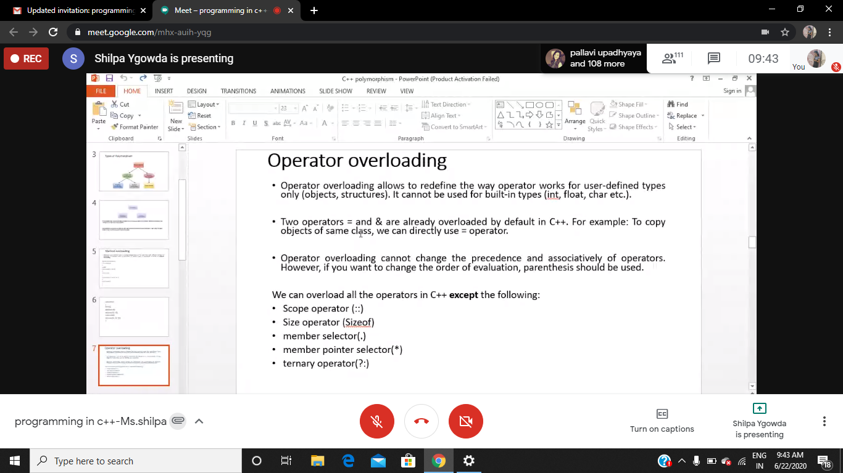

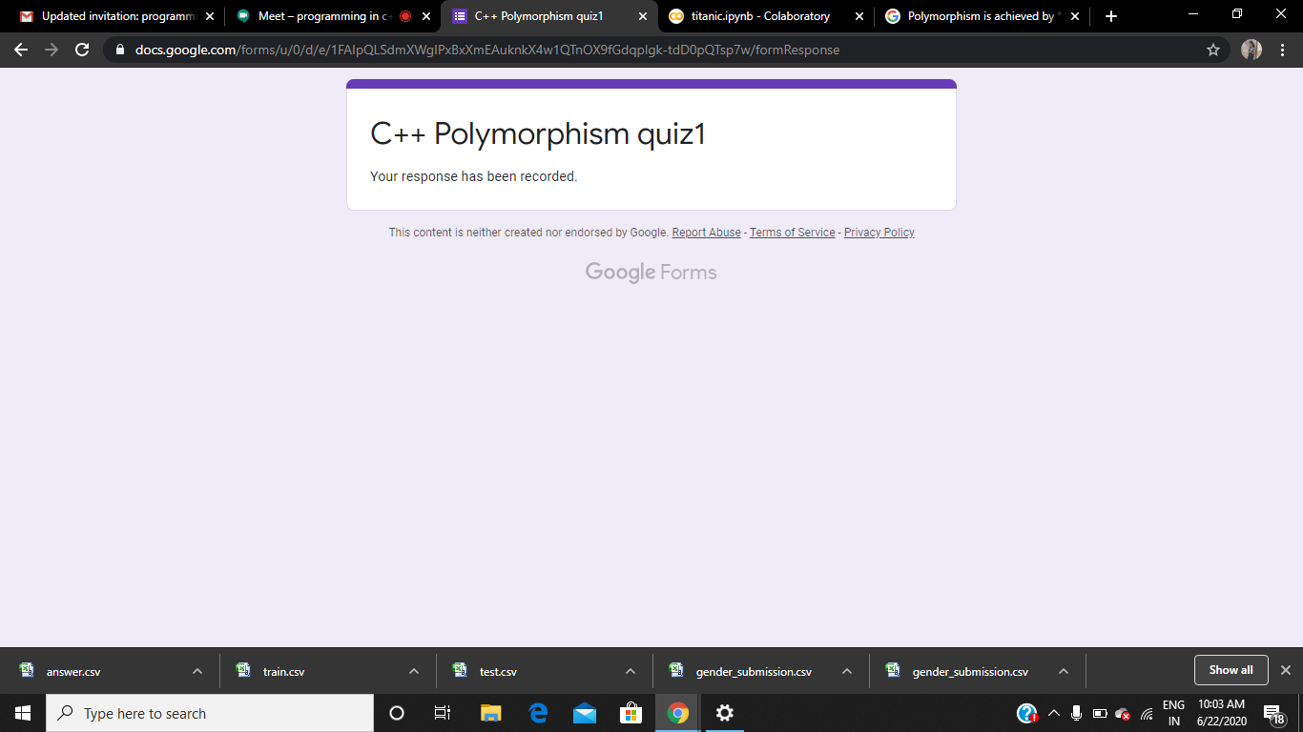

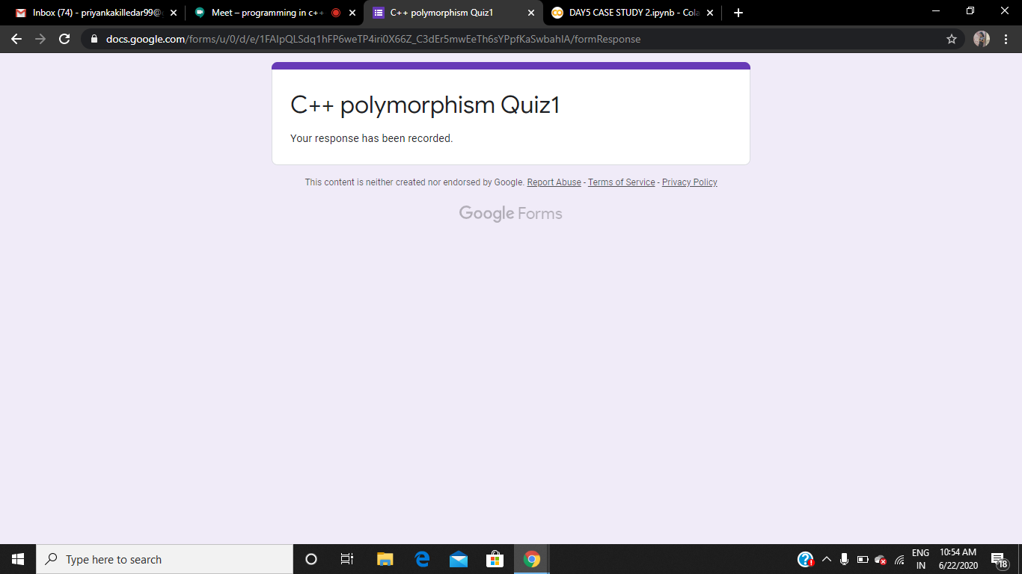

**Cpp programming (time 11 to 1): Constructor and Inheritance**

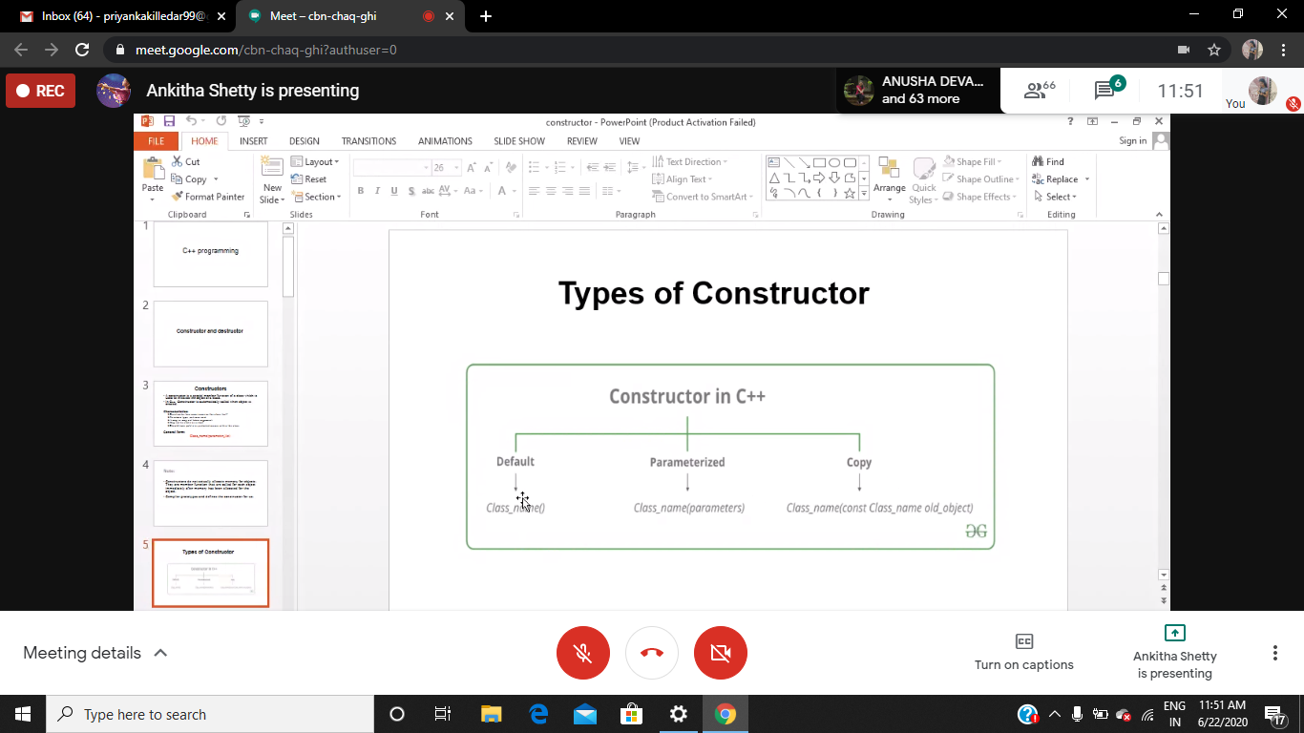

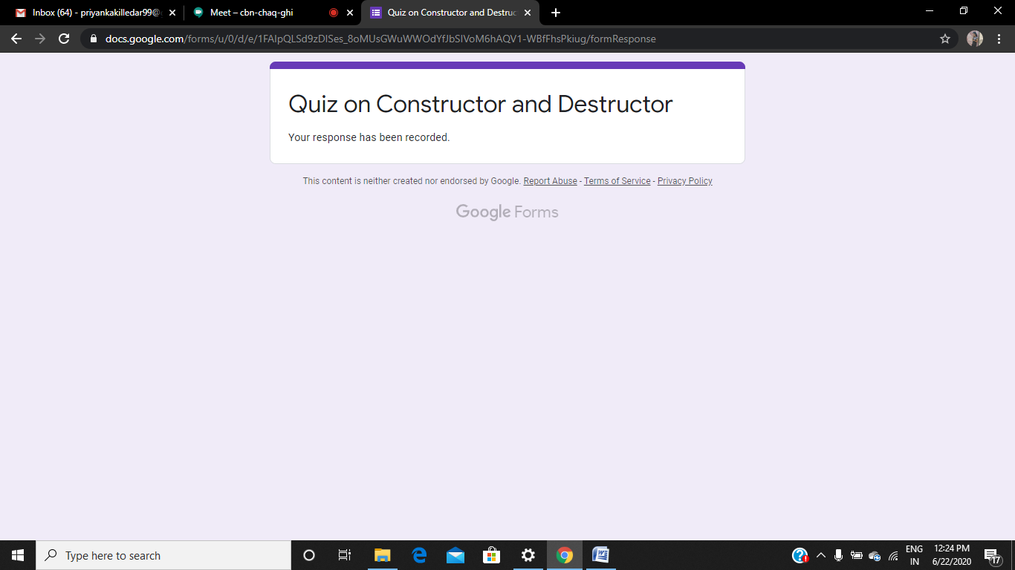

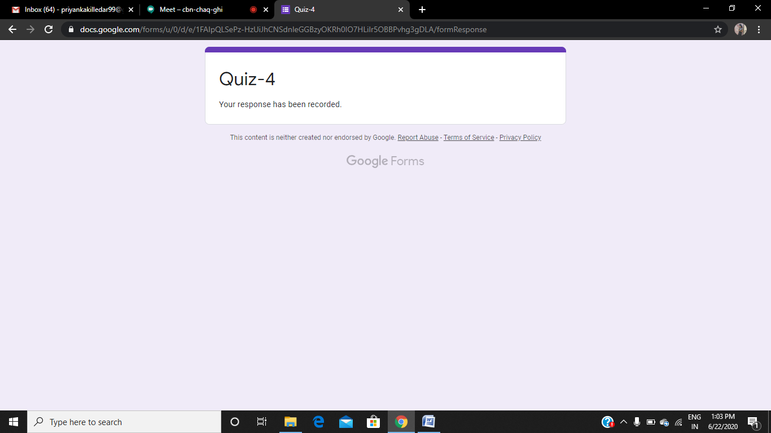

**Coding Challenges Details:**

Refer the github link for detail information :<https://github.com/Priya-s-k/Online-coding-updates>

Solved all the problems and the solutions are uploaded in github account.

the same report is also available in github: <https://github.com/Priya-s-k/online-activity-updates>